**REPUBLIQUE DU CAMEROON**

**PAIX-Travail-Patrie**

**MINISTRE DE L’ENSEIGNEMENT SUPERIEUR**

**FACULTE D’INGENIERIE**

**ET DE TECHNOLOGIE**



**REPUBLIC OF CAMEROON**

**Peace-Work-Fatherland**

**MINISTER OF HIGHER EDUCATION**

**FACULTY OF ENGINEERING**

**AND TECHNOLOGY**

***\*\*\*\*\*\*\*\*\*\*\*\*\*\*\*\*\*\*\*\** THE UNIVERSITY OF BUEA*\*\*\*\*\*\*\*\*\*\*\*\*\*\*\*\*\*\*\*\****

**DEPARTMENT OF COMPUTER ENGINEERING**

**COURSE: INTERNET AND MOBILE PROGRAMMING**

**COURSE CODE: CEF440**

**TASK 5**

**UI DESIGN AND IMPLEMENTATION OF PASSENGER POSITIONING SYSTEM (DIGITEKISI)**

**INSTRUCTOR: Dr. NKEMENI VALERY**

**May 2023**

|  |  |
| --- | --- |
| **NAME** | **MATRICULE NO** |
| YIMNAI NERUS ZAUMU | FE20A123 |
| TABOT CHARLES BESSONG | FE20A106 |
| BEBONGNCHU YANNICK NKWETTA | FE20A022 |
| BALEMBA JUNIOR BALEMBA | FE20A021 |
| TANDONGFOR SHALOM CHANGEH | FE20A111 |

Contents

**Introduction** 3

**Implementation:** 7

**Interfaces`** 11

**Interface Description** 14

**UI DESIGN AND IMPLEMENTATION OF PASSENGER POSITIONING SYSTEM (DIGITEKISI)**

# **Introduction**

The UI design phase is the process of designing a software system’s user interface (UI). The UI is the part of the system that users interact with, and it includes things like the layout, colors, fonts, and icons. The goal of UI design is to create a UI that is easy to use and understand and helps users achieve their goals.

The UI design phase typically includes the following steps:

1. **Research**: The first step is to research the users and their needs. This includes understanding their goals, their tasks, and their preferences.
2. **Brainstorming**: Once the user research is complete, the designers can start brainstorming ideas for the UI. This is a creative process where the designers come up with different possibilities.
3. **Prototyping**: Once some ideas have been developed, the designers can create prototypes of the UI. Prototypes can be made using paper, wireframes, or software.
4. **Testing**: Once the prototypes are created, they need to be tested with users. This helps to ensure that the UI is easy to use and understand.
5. **Iteration**: The design process is iterative, which means that it involves repeating steps. Based on the feedback from users, the designers may need to go back and make changes to the UI.
6. **Implementation:** Once the UI is tested and approved, it can be implemented in the software system.

The UI design phase is an important part of the software development process. A well-designed UI can make a software system more user-friendly and easier to use. This can lead to increased productivity, satisfaction, and loyalty among users.

There are a number of different technologies and tools that can be used for UI design. Some of the most popular include:

* Adobe XD
* Figma
* Sketch
* InVision
* Balsamiq Mockups

These tools allow designers to create wireframes, mockups, and prototypes of their designs. They also offer a variety of features that can help designers to collaborate with other team members and get feedback on their designs.

The UI design phase of a software system is an important step in the development process. A well-designed user interface can make a big difference in the success of a software product. By using the right technologies and tools, designers can create user interfaces that are both effective and visually appealing.

Here are some of the benefits of UI design:

* **Improved user experience**: A well-designed user interface can make a software product more enjoyable and easy to use. This can lead to increased user satisfaction and loyalty.
* **Increased productivity**: A user-friendly interface can help users to complete tasks more quickly and efficiently. This can lead to increased productivity and profits.
* **Reduced costs**: A well-designed user interface can help to reduce the cost of development and support. This is because it is easier to maintain and update a user interface that is well-designed.

Here are some of the challenges of UI design:

* **Balancing usability and aesthetics**: It is important to find a balance between usability and aesthetics. The user interface should be easy to use, but it should also be visually appealing.
* **Meeting user needs**: The user interface should meet the needs of the target users. This requires understanding the users' goals and tasks, as well as their abilities and limitations.
* **Keeping up with trends**: The user interface should keep up with the latest trends in design. This can be a challenge, as trends can change quickly.

Overall, UI design is an important part of the software development process. A well-designed user interface can make a software product more enjoyable and easy to use, which can lead to increased user satisfaction and loyalty.

The UI implementation phase of a software system is the process of converting the UI design into code. This includes everything from creating the user interface elements to adding interactivity. The goal of UI implementation is to create a user interface that is faithful to the design and that works as expected.

There are a number of different technologies and tools that can be used for UI implementation. Some of the most popular include:

* HTML
* CSS
* JavaScript
* React JS
* Angular
* Vue.js
* React Native

These technologies allow developers to create interactive user interfaces that can be displayed in a web browser or on a mobile device.

The UI implementation phase of a software system is an important step in the development process. A well-implemented user interface can make a big difference in the success of a software product. By using the right technologies and tools, developers can create user interfaces that are both effective and visually appealing.

Here are some of the benefits of UI implementation:

* **Improved user experience**: A well-implemented user interface can make a software product more enjoyable and easy to use. This can lead to increased user satisfaction and loyalty.
* **Increased productivity**: A user-friendly interface can help users to complete tasks more quickly and efficiently. This can lead to increased productivity and profits.
* **Reduced costs**: A well-implemented user interface can help to reduce the cost of development and support. This is because it is easier to maintain and update a user interface that is well-implemented.

Here are some of the challenges of UI implementation:

* **Coordinating with other team members**: The UI implementation phase often involves coordinating with other team members, such as designers, developers, and testers. This can be challenging, as everyone may have different ideas about how the user interface should look and work.
* **Meeting user needs**: The UI implementation phase should meet the needs of the target users. This requires understanding the users' goals and tasks, as well as their abilities and limitations.
* **Keeping up with trends**: The UI implementation phase should keep up with the latest trends in design. This can be a challenge, as trends can change quickly.

Overall, UI implementation is an important part of the software development process. A well-implemented user interface can make a software product more enjoyable and easy to use, which can lead to increased user satisfaction and loyalty.

Here are some of the steps involved in the UI implementation phase:

1. **Create wireframes**: Wireframes are low-fidelity representations of the user interface. They are used to quickly and easily communicate the design to developers and other team members.
2. **Create mockups**: Mockups are high-fidelity representations of the user interface. They are used to get feedback from users and to make sure that the design is working as expected.
3. **Create code**: The code is the actual implementation of the user interface. It is written using HTML, CSS, and JavaScript.
4. **Test the user interface**: The user interface should be tested to make sure that it is working as expected. This includes testing the functionality, the usability, and the accessibility.
5. **Deploy the user interface**: Once the user interface is tested and approved, it can be deployed to production.

By following these steps, one can create a well-implemented user interface that will make your software product more enjoyable and easy to use.

# **Implementation:**

For the UI design of our UI Design, we used **User-centered design (UCD)** which is a methodology that focuses on the needs of the user. It involves understanding the user's goals, tasks, and abilities, and then designing a user interface that meets those needs.

The reasons why we used the User-centered design methodology include:

* **To create a product that is easy to use**: UCD can help to ensure that a product is easy to use by understanding the user's goals and tasks. This can help to identify any potential usability issues and make sure that the product is designed in a way that is easy for users to understand and use.
* **To create a product that is effective**: UCD can help to ensure that a product is effective by understanding the user's goals and tasks. This can help to identify any potential features that are not needed or that are not effective, and make sure that the product is designed in a way that helps users to achieve their goals.
* **To create a product that is enjoyable to use**: UCD can help to ensure that a product is enjoyable to use by understanding the user's goals and tasks. This can help to identify any potential design elements that are not enjoyable or that are not effective, and make sure that the product is designed in a way that is enjoyable for users to use.
* **To create a product that is accessible to all users**: UCD can help to ensure that a product is accessible to all users by understanding the needs of users with disabilities. This can help to identify any potential design elements that are not accessible or that are not effective, and make sure that the product is designed in a way that is accessible to all users.

Overall, UCD is a valuable design methodology that can help to create products that are easy to use, effective, enjoyable, and accessible to all users.

Here are some of the benefits of using UCD that caught our attention:

* **Increased user satisfaction:** Users are more likely to be satisfied with a product that is designed with their needs in mind.
* **Reduced development costs:** By identifying and addressing usability issues early in the design process, UCD can help to reduce the cost of development.
* **Improved product quality**: UCD can help to ensure that a product is of high quality by making sure that it meets the needs of the user.
* **Increased market share:** By designing a product that is easy to use and effective, UCD can help to increase market share.

Overall, UCD is a valuable design methodology that can help to improve the quality, usability, and marketability of a product.

We used **Figma** for the creation of our User Interfaces.

Figma is a popular design tool that is used by designers and developers to create user interfaces (UIs). It is a web-based tool, which means that it can be accessed from anywhere with an internet connection. This makes it a convenient option for teams that are working remotely or that have members in different locations.

We used figma due to numerous reasons. Figma offers a number of features that make it a good choice for UI design, including:

* **Real-time collaboration:** Figma allows multiple users to work on the same design at the same time. This can be helpful for teams that need to get feedback on designs quickly.
* **Vector graphics**: Figma uses vector graphics, which means that designs can be scaled to any size without losing quality. This is important for creating high-resolution designs for websites and mobile apps.
* **Component library:** Figma includes a component library that can be used to create reusable components. This can save time and effort when designing complex UIs.
* **Prototyping**: Figma can be used to create interactive prototypes of designs. This can be helpful for testing designs with users and getting feedback.
* **Accessibility**: Figma has built-in accessibility features that can be used to make designs more accessible to users with disabilities.

Overall, Figma is a powerful tool that can be used to create high-quality UIs. It is a good choice for teams that are looking for a web-based tool that offers real-time collaboration, vector graphics, a component library, prototyping, and accessibility features.

Also, Here are some of the reasons why we chose Figma for the creation of our UI:

* **It is a web-based tool**: This means that it can be accessed from anywhere with an internet connection, which is convenient for teams that are working remotely or that have members in different locations.
* **It is easy to use:** Figma has a user-friendly interface that makes it easy to learn and use, even for beginners.
* **It is affordable**: Figma offers a free plan that is suitable for personal use, and a paid plan that is more suitable for businesses.
* **It has a large community**: Figma has a large and active community of users who share resources, tips, and tricks. This can be helpful for learning more about Figma and getting help with problems.

For the implementation of our UI, we used the **ReactNative** technology.

React Native is a popular framework for building native mobile apps using JavaScript. It is based on React, a popular JavaScript library for building user interfaces. React Native uses a bridge to communicate with the native Android and iOS APIs, which allows developers to build apps that look and feel like native apps.

We used React Native for a number of reasons, some of which include:

* **Speed**: React Native is a fast framework that can be used to build apps quickly.
* **Efficiency**: React Native is an efficient framework that uses native components, which means that apps built with React Native can be as fast as native apps.
* **Flexibility**: React Native is a flexible framework that can be used to build a wide variety of apps.
* **Community**: React Native has a large and active community of developers who share resources, tips, and tricks.
* **Cost**: React Native is a free and open-source framework, which means that it is a cost-effective option for building mobile apps.

Overall, React Native is a good choice for anyone who needs to build a mobile app. It is fast, efficient, flexible, has a large community, and is free and open-source.

Also, some of the specific benefits of using React Native for UI implementation include:

* **Reusability**: React Native components are reusable, which can save time and effort when building complex UIs.
* **Performance**: React Native apps are typically as fast as native apps, which can provide a better user experience.
* **Ease of development**: React Native is a relatively easy framework to learn and use, which can make it a good choice for teams with limited development resources.
* **Cross-platform support**: React Native apps can be built for both Android and iOS, which can save time and money by eliminating the need to develop two separate apps.

Overall, React Native is a good choice for any team that needs to build a mobile app with a high-quality UI. It is fast, easy to use, and supports both Android and iOS.

# **Interfaces****`**

3.Walkthrough

2.WalkThrough

1.Welcome

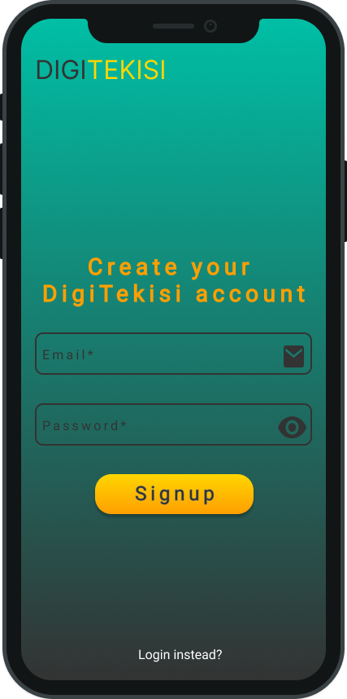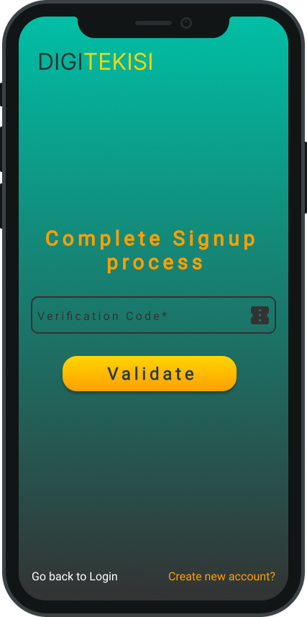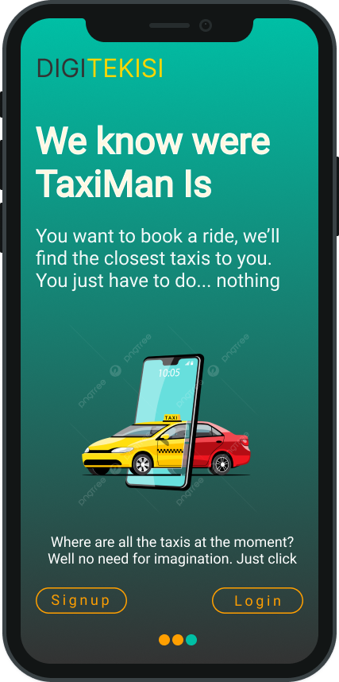

6.ValidateSignup

4.Walkthrough

5.Signup

9.ResetPassword

8.ForgotPassword

7.Login

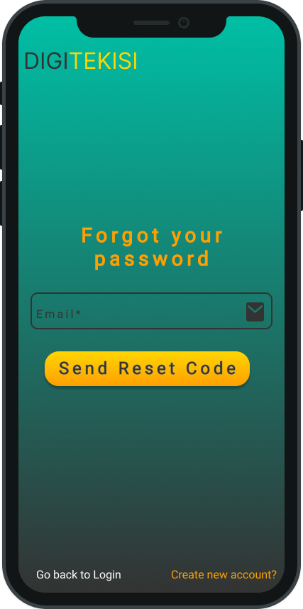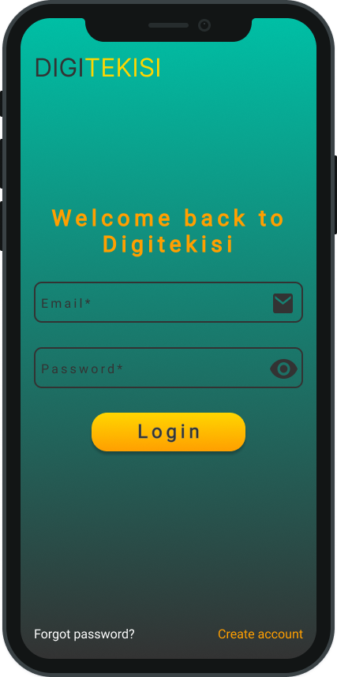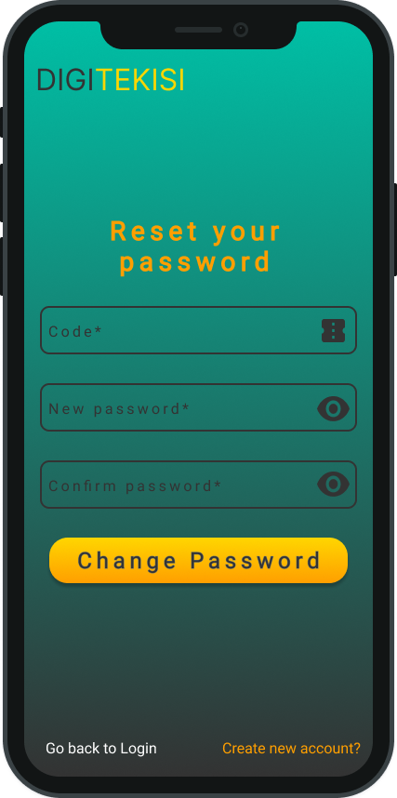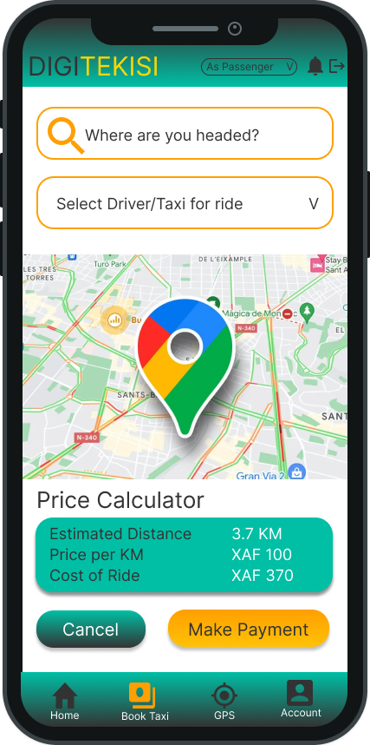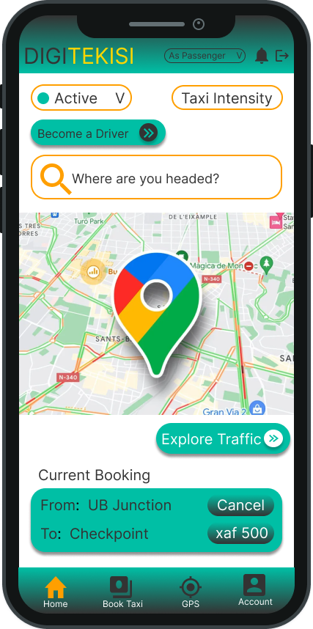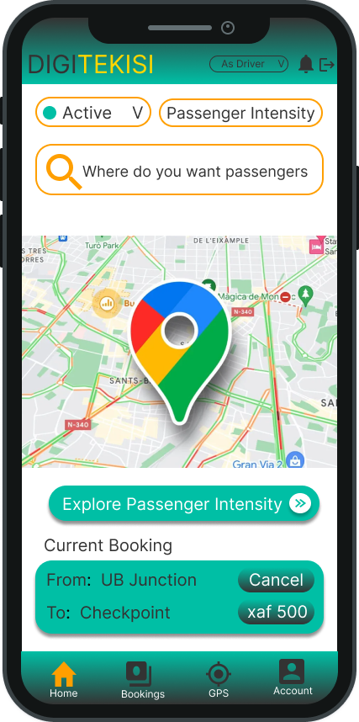

12.Bookride

11.DriverHomepage

10.PassengerHomepage

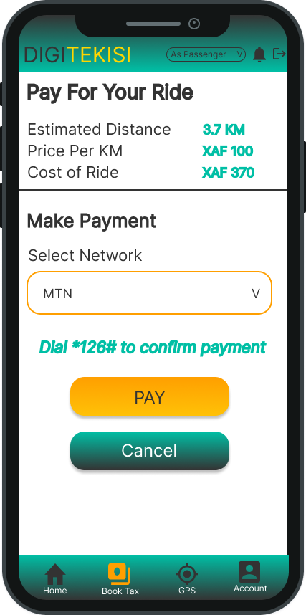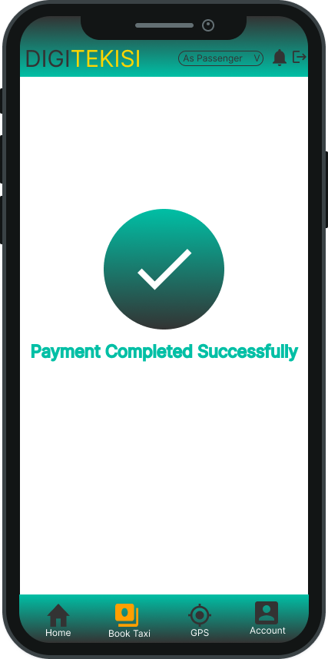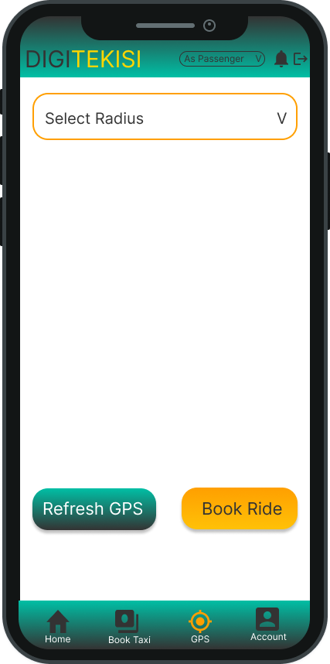

15.PassengerGPS

14.SuccessfulPayment

13.PayForRide

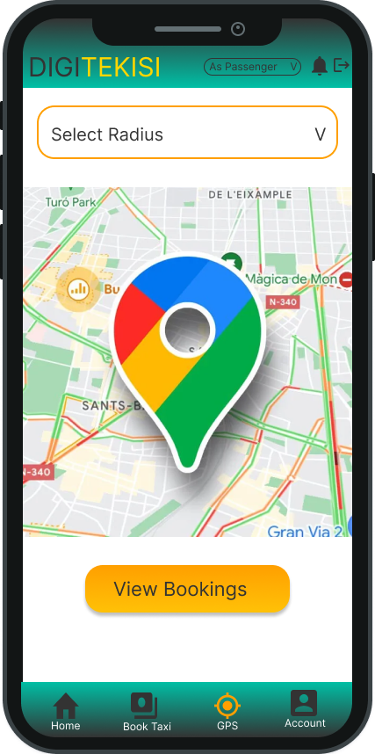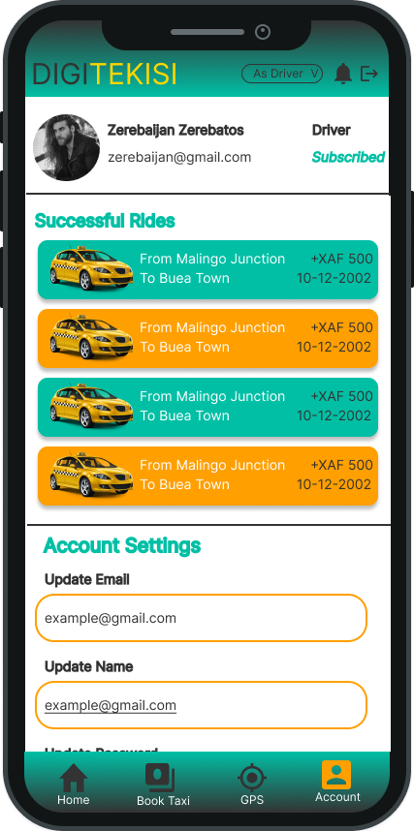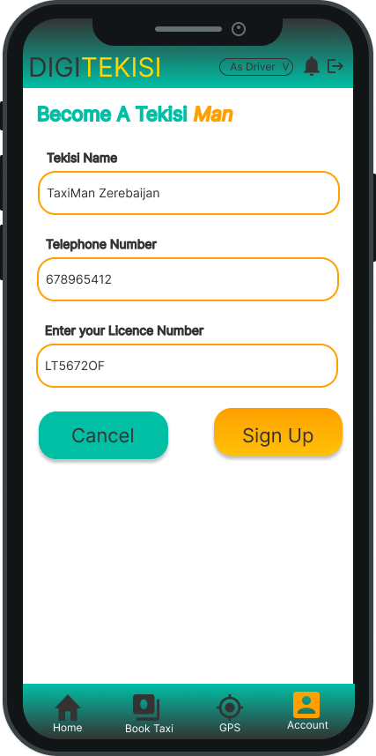

17.Become a driver

17.TaxiHome

16.DriverGPS

# **Interface Description**

**Welcome Section**

This section comprises Screens 1, 2, 3, and 4.

The user (passenger or driver) is welcome into the application with a Get Started page. The page is designed in such a way that it gives the user the feel of what services the system will provide for them. There is a get started button that will take the user to other pages where they will see all the advantages the application will offer to them. Advantages such as

* Not waiting in traffic
* No change issues
* Waiting long hours

In those pages to help the user navigate from one advantage to another, we added navigation for the user to move from one page to another page. Also keeping in mind that not every User will love to see the boring advantages especially if they already know what the system offers, we added a skip button that will navigate the user directly to the homepage.

**Authentication section**

This section comprises Screens 5, 6, 7, 8, and 9.

The first time the user opens the app, they will not be prompted to create an account. They will have the chance of viewing the homepage. But when they will want to view available rides or become a driver or book a ride, then they will need to create an account. Creating an account will be very important as we will need to keep track of each user’s activities and be able to bill them or pay them for every ride. For the account creation, we need just the user email and password.

The email will be used to uniquely identify the user. When next the user opens the app after they already have an account, logging in will be the only they will have to do. For the login, only the email and password will also be required. When logging in or signing up, we have added errors to be displayed on the screen to show the user where they made a mistake or did not input the correct value.

For example when signing up, if the email already existed the use will be shown an error stating that that email has already been taken by another user. As for the password to make the system secure, we have chosen a strong password pattern which if the user does not follow when creating their account, they will be shown an error telling them what's left to make the password complete.

To avoid buts entering our system, we have added a verification of account which will just require a user to enter the code sent to them in the verification mail via the mail they used to create their account.

As humans, we tend to forget, but we did not want to forget that important aspect of our users. So we implemented a UI section that will enable them to change their password if they have forgotten the old one. But to avoid people from stealing other people's accounts, the user will have to enter their email so that we send them a verification code with a unique code they will use to change their password.

**Maps section**

This section comprises Screens 10, 11, 12, 14, 15.

We have thought of making the experience easy for our users as much as possible. Whenever the passenger wants to book a ride, they have a map interface that helps them select their location and destination. For the location and destination, they will just have to either enter it as text input or select it as an option from our different clusters. Once the passenger has chosen their destination and present location, the total distance of the journey is calculated and displayed to the user.

**Payment section**

This section comprises Screens 12, and 13.

The passenger chooses a method of payment and pays the driver. The driver receives a notification when the payment is complete.

**Apply as driver section**

This section comprises Screens 10, 16, and 17.

Every User who creates an account for the first time is considered as a passenger, to become a driver, you will have to fill in additional information.